**LONG ANSWERS**

1. Differentiate between LAN, MAN, and WAN.

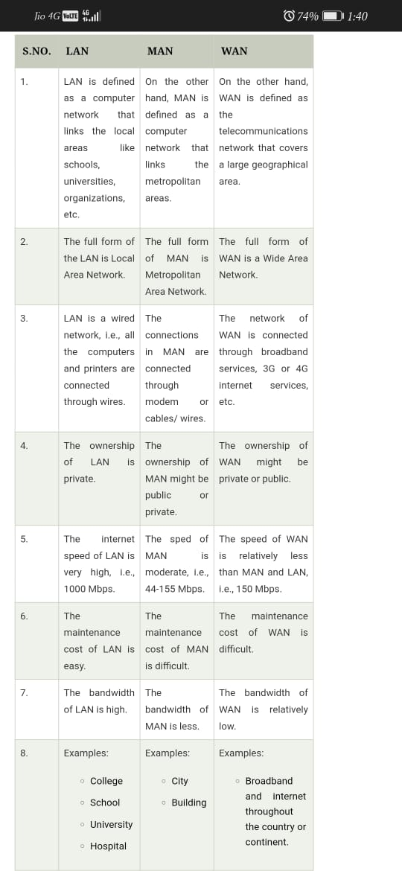

1. Compare and contrast the OSI and TCP/IP reference models

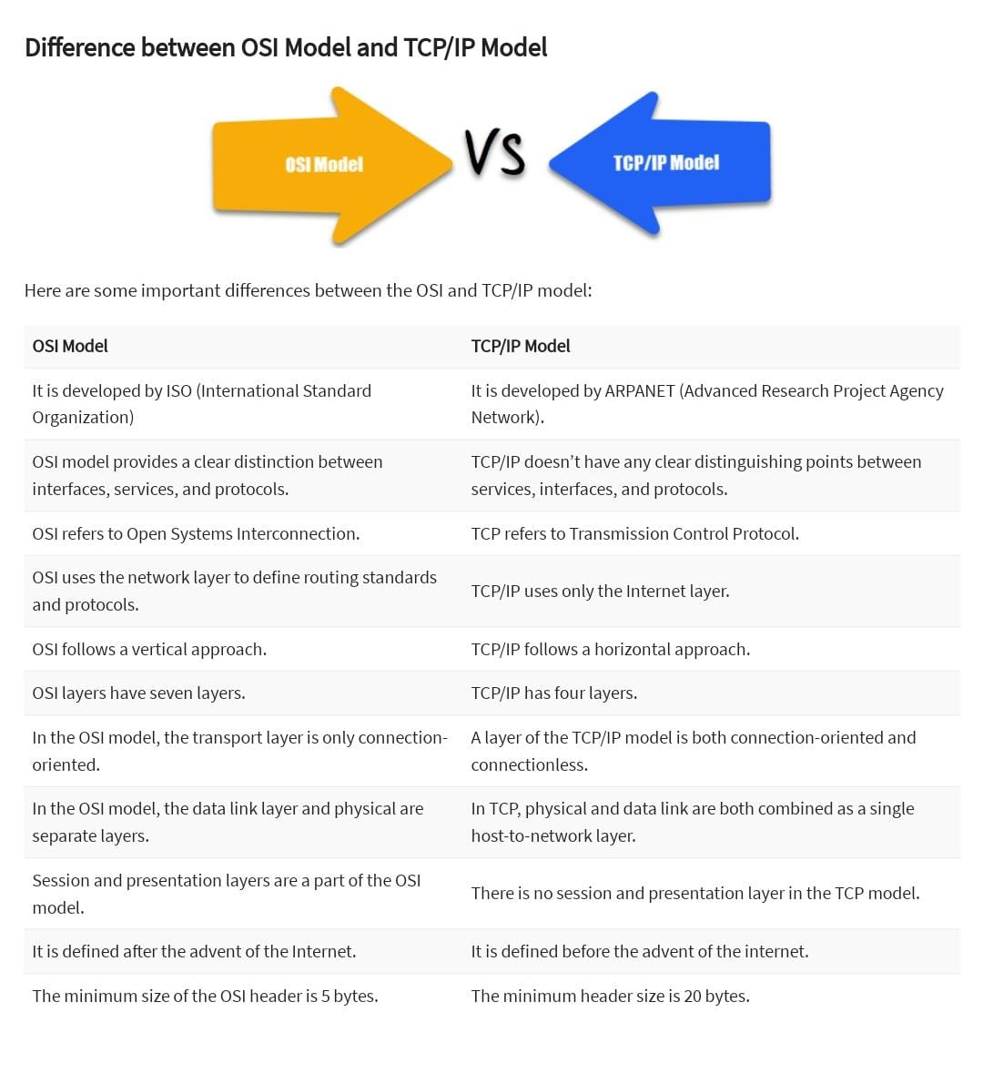

1. Discuss the various transmission media available at the physical layer.

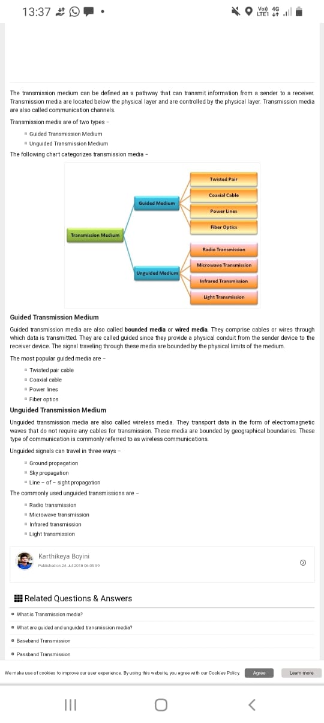

1. Elaborate on the mobile telephone system.

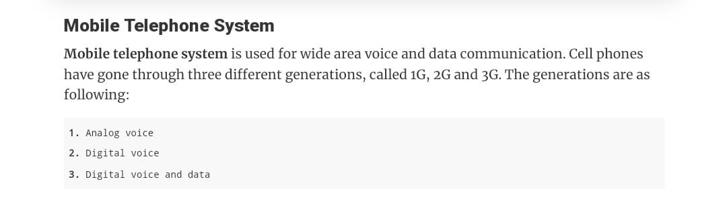

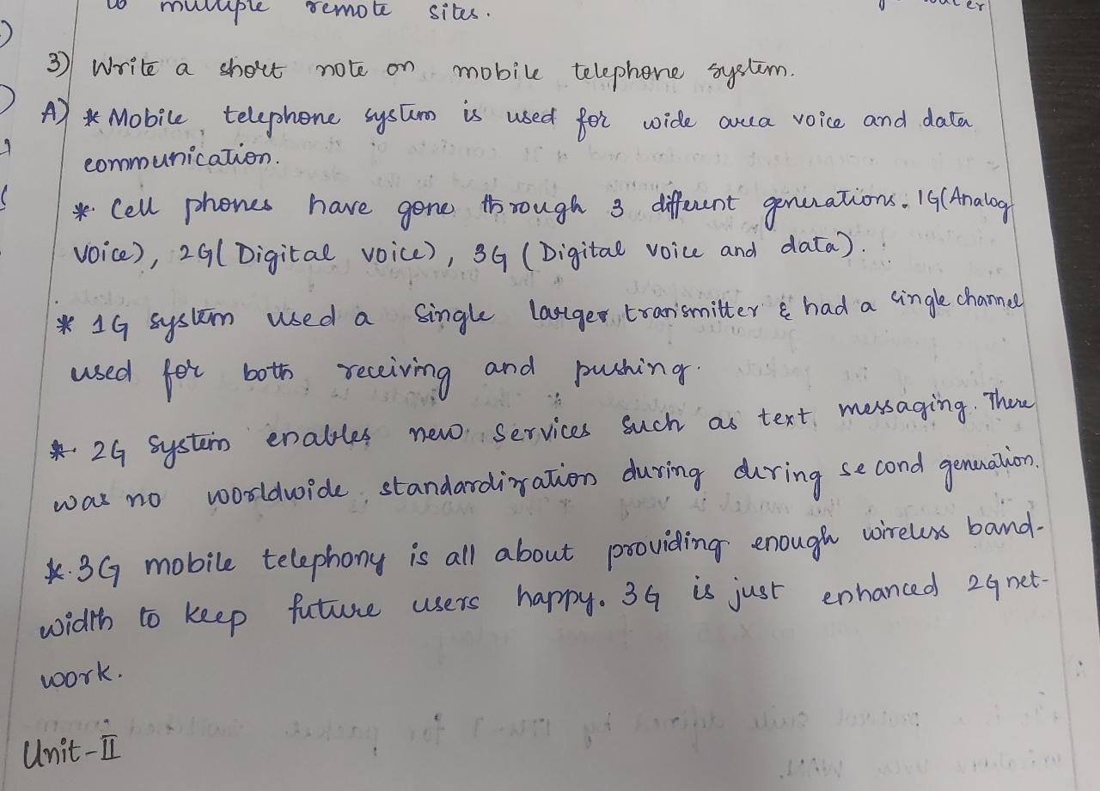

1. Explain about Go Back N Sliding Window Protocol.

In Go-Back-N ARQ, **N** is the sender's window size.

It uses the principle of protocol pipelining in which the multiple frames can be sent before receiving the acknowledgment of the first frame.

In Go-Back-N ARQ, the frames are numbered sequentially as Go-Back-N ARQ sends the multiple frames at a time that requires the numbering approach to distinguish the frame from another frame, and these numbers are known as the sequential numbers.

The number of frames that can be sent at a time totally depends on the size of the sender's window. So, we can say that 'N' is the number of frames that can be sent at a time before receiving the acknowledgment from the receiver.

If the acknowledgment of a frame is not received within an agreed-upon time period, then all the frames available in the current window will be retransmitted.

The sequence number of the outbound frames depends upon the size of the sender's window.

Working of Go-Back-N ARQ

Suppose there are a sender and a receiver, and let's assume that there are 11 frames to be sent. These frames are represented as 0,1,2,3,4,5,6,7,8,9,10, and these are the sequence numbers of the frames. Mainly, the sequence number is decided by the sender's window size. But, for the better understanding, we took the running sequence numbers, i.e., 0,1,2,3,4,5,6,7,8,9,10. Let's consider the window size as 4, which means that the four frames can be sent at a time before expecting the acknowledgment of the first frame.

**Step 1:** Firstly, the sender will send the first four frames to the receiver, i.e., 0,1,2,3, and now the sender is expected to receive the acknowledgment of the 0th frame.

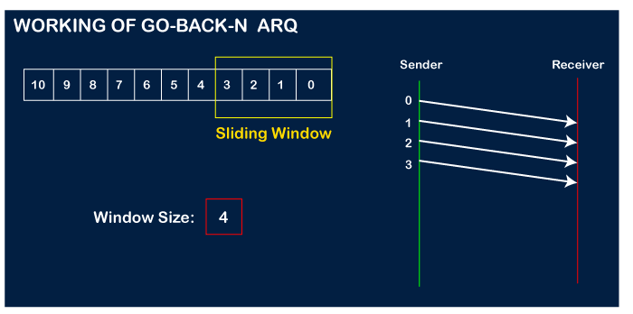

Let's assume that the receiver has sent the acknowledgment for the 0 frame, and the receiver has successfully received it.

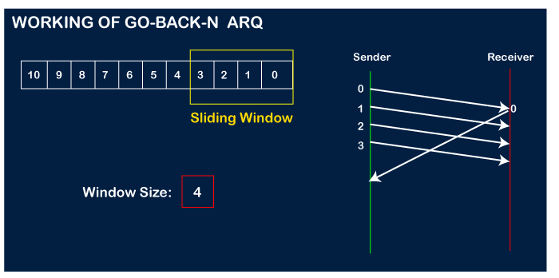

The sender will then send the next frame, i.e., 4, and the window slides containing four frames (1,2,3,4).

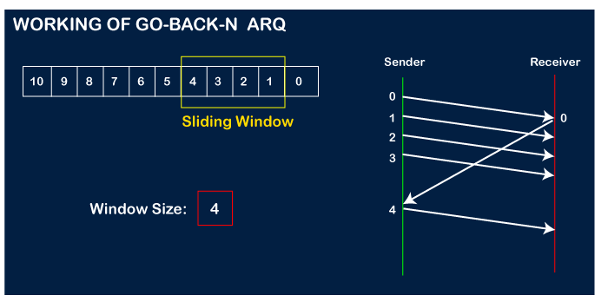

The receiver will then send the acknowledgment for the frame no 1. After receiving the acknowledgment, the sender will send the next frame, i.e., frame no 5, and the window will slide having four frames (2,3,4,5).

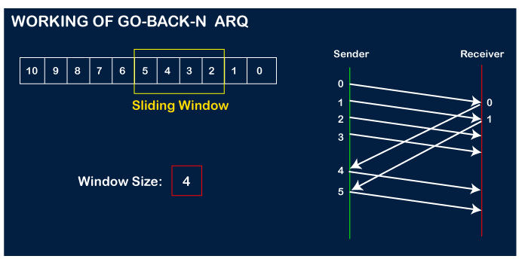

Now, let's assume that the receiver is not acknowledging the frame no 2, either the frame is lost, or the acknowledgment is lost. Instead of sending the frame no 6, the sender Go-Back to 2, which is the first frame of the current window, retransmits all the frames in the current window, i.e., 2,3,4,5.

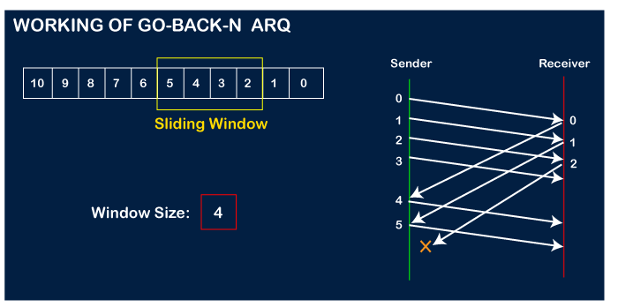  
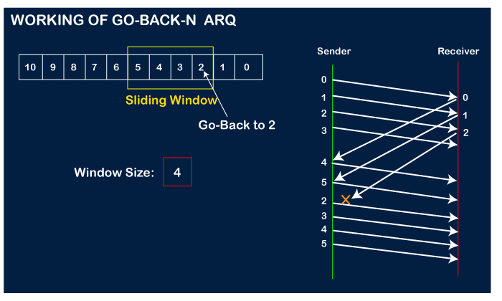

Important points related to Go-Back-N ARQ:

* In Go-Back-N, N determines the sender's window size, and the size of the receiver's window is always 1.
* It does not consider the corrupted frames and simply discards them.
* It does not accept the frames which are out of order and discards them.
* If the sender does not receive the acknowledgment, it leads to the retransmission of all the current window frames.

1. Explain channel allocation problems.

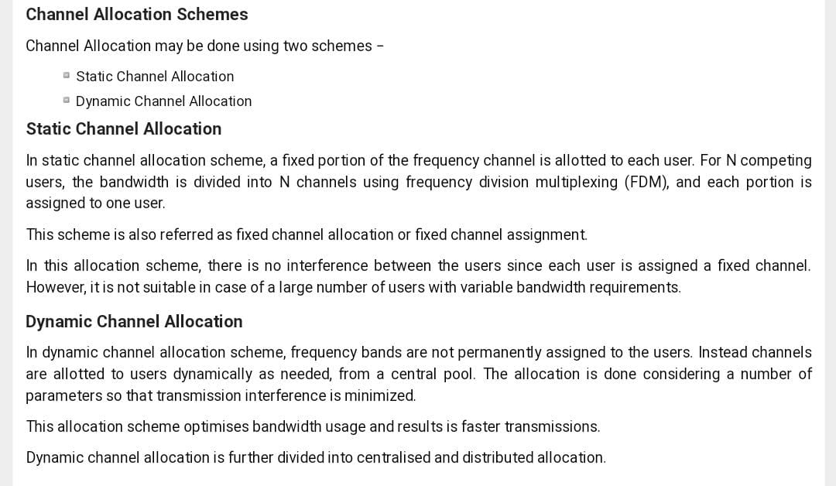

1. Explain channel allocation problems. What are the different types of error detection methods? Explain the CRC error detection technique using generator polynomial x4+x3+1 and data 11100011.
2. Explain Byte Stuffing and Bit Stuffing?

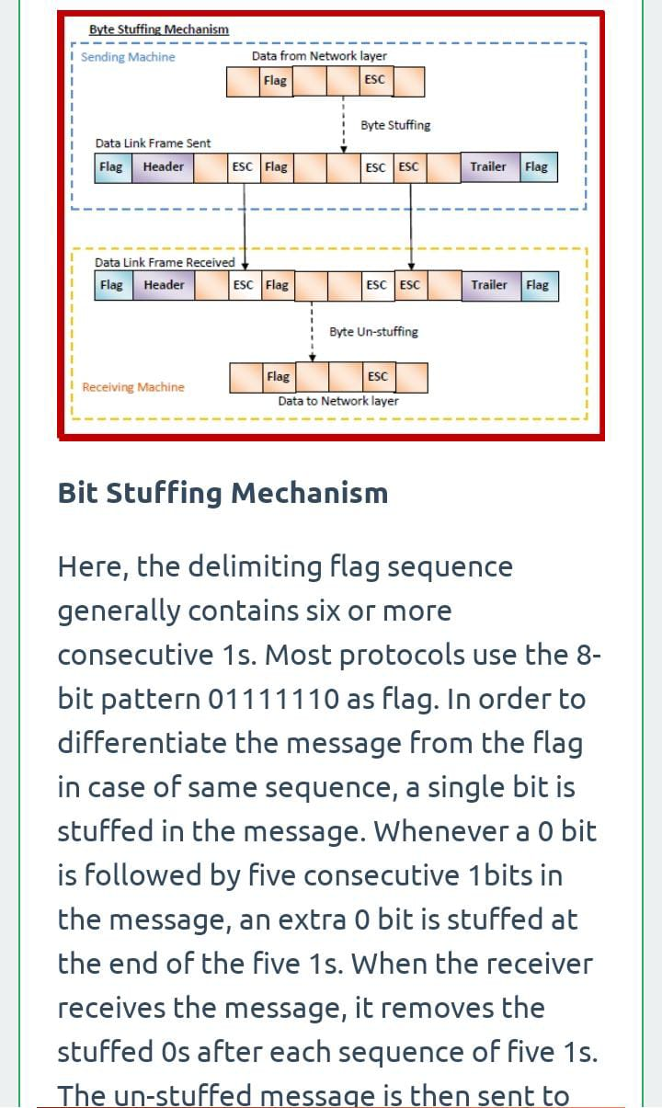

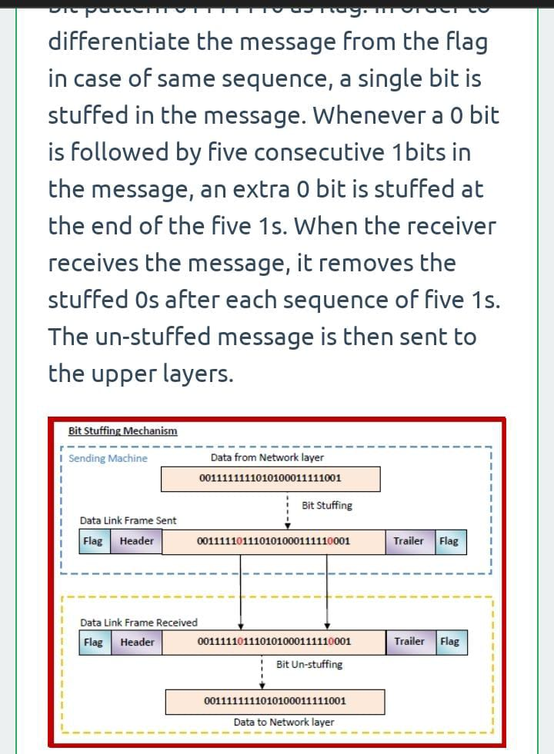

1. Discuss Network layer design issues.

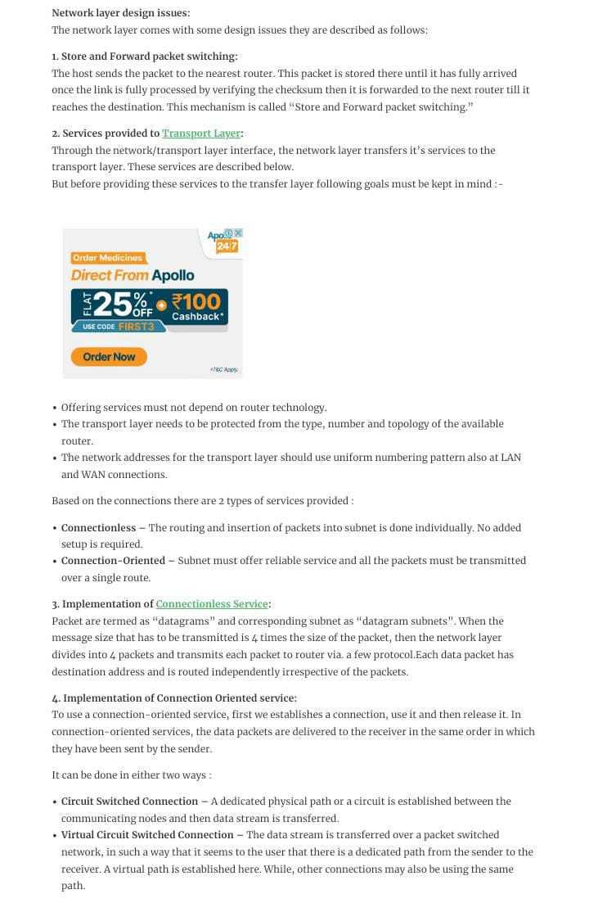

1. With an example, explain shortest path routing.

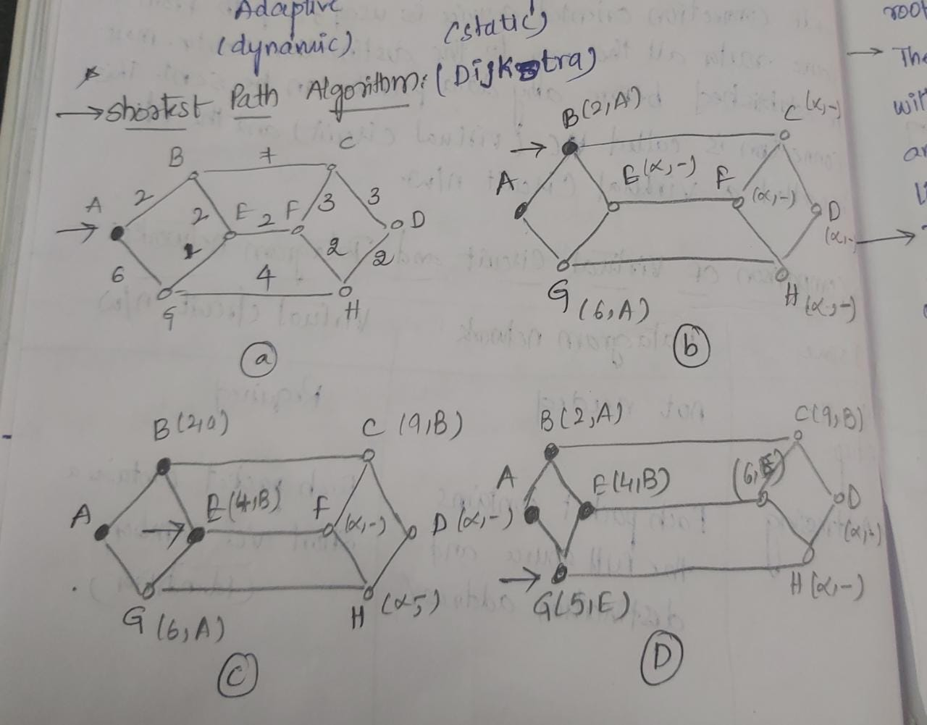

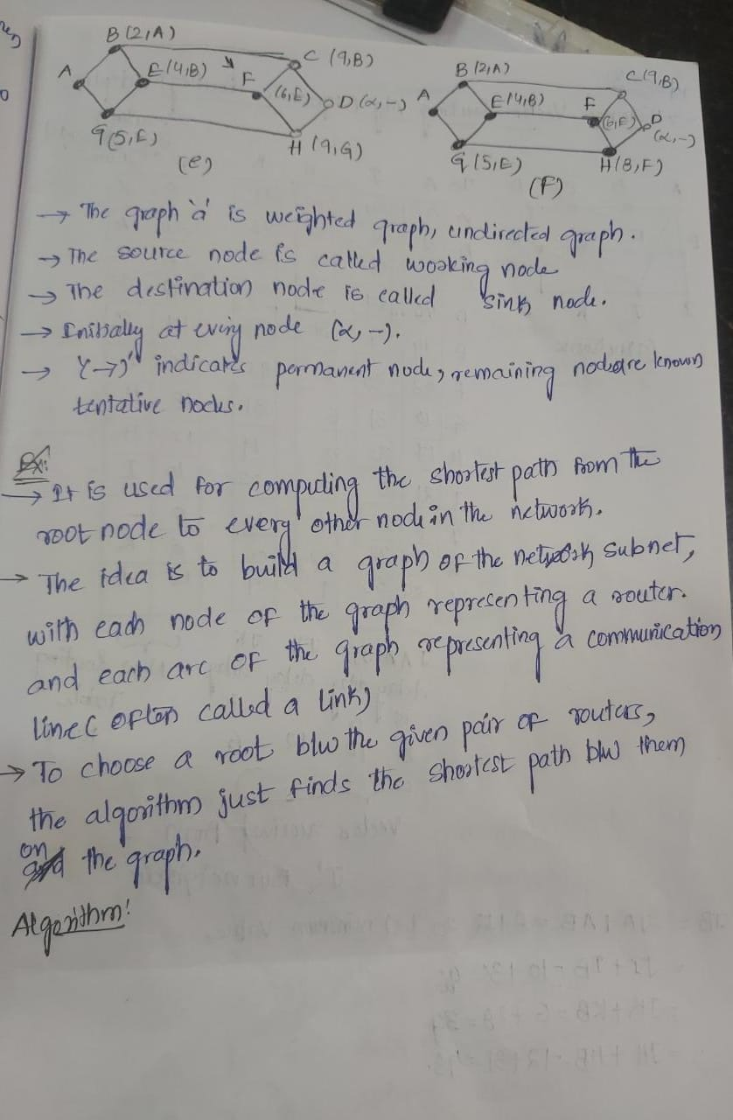

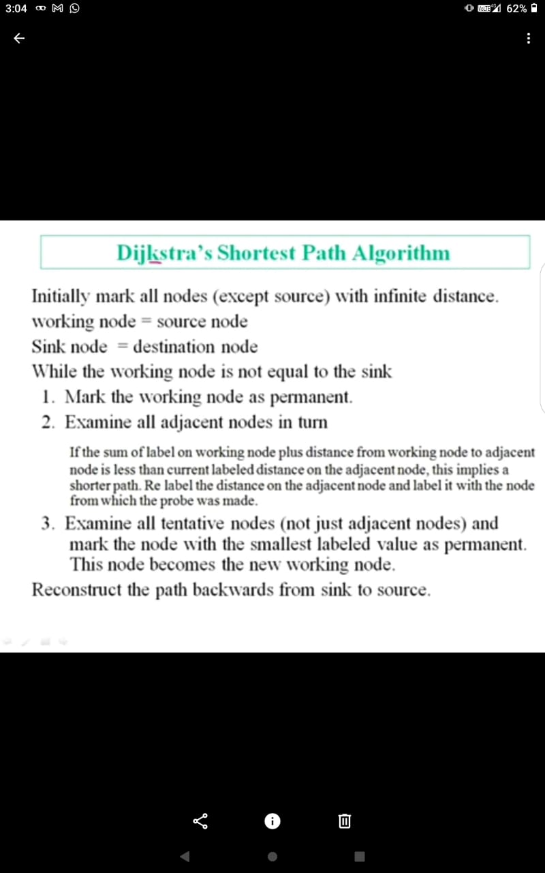

1. Explain the ISO-OSI model of computer networks with a neat diagram.
2. Explain any three types of Wireless Transmission Media.

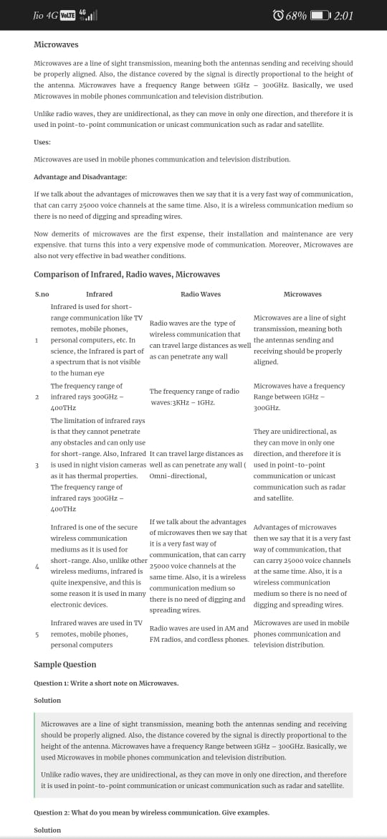

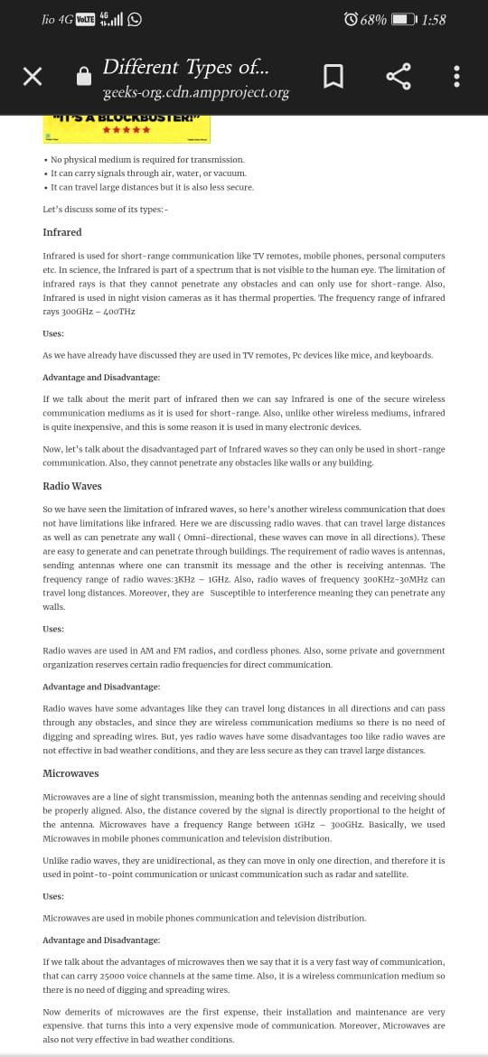

1. Describe briefly Connection-Oriented X.25 and Frame Relay.

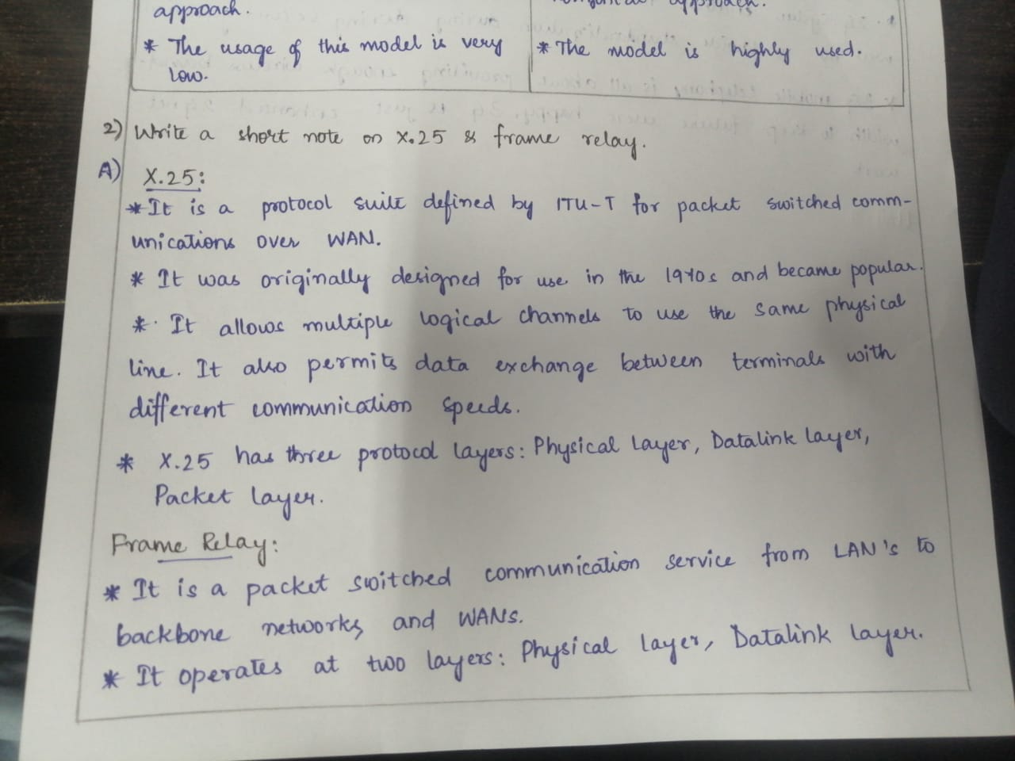

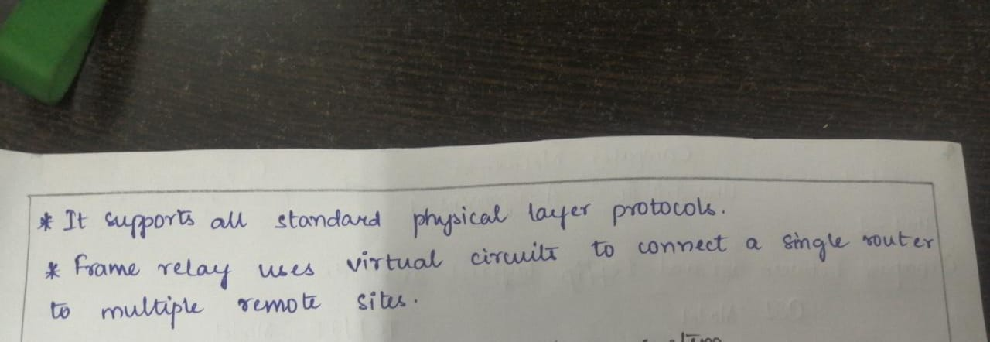

1. Demonstrate Hamming Code with an Example.

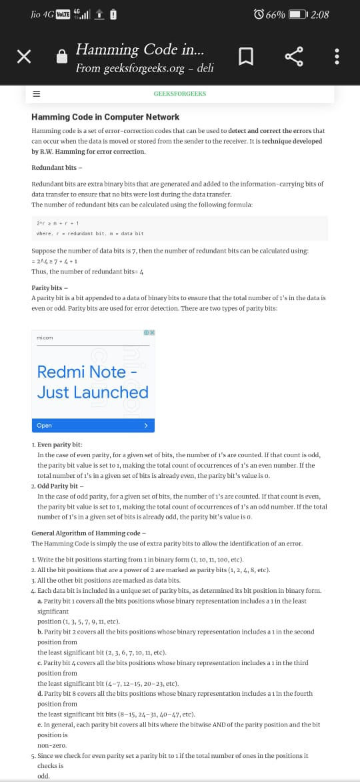

1. What is the purpose of CSMA CD? And Explain it.

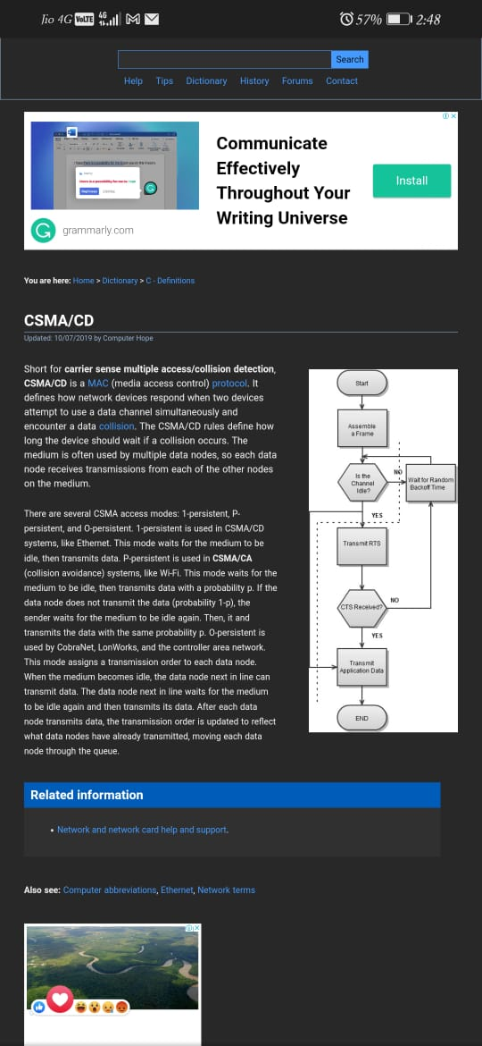

1. Explain and demonstrate Selective repeat sliding window Protocol with an example.

## Selective Repeat ARQ

It is also known as Sliding Window Protocol and used for error detection and control in the data link layer.

In the selective repeat, the sender sends several frames specified by a window size even without the need to wait for individual acknowledgement from the receiver as in Go-Back-N ARQ. In selective repeat protocol, the retransmitted frame is received out of sequence.

In Selective Repeat ARQ only the lost or error frames are retransmitted, whereas correct frames are received and buffered.

The receiver while keeping track of sequence numbers buffers the frames in memory and sends NACK for only frames which are missing or damaged. The sender will send/retransmit a packet for which NACK is received.

## Example

Given below is an example of the Selective Repeat ARQ −

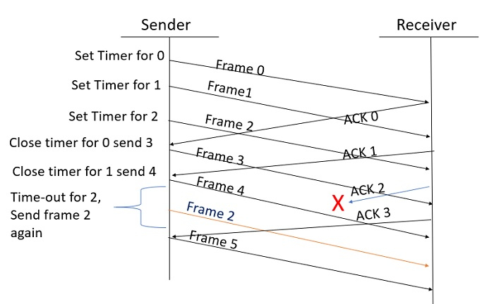

## Explanation

**Step 1** − Frame 0 sends from sender to receiver and set timer.

**Step 2** − Without waiting for acknowledgement from the receiver another frame, Frame1 is sent by sender by setting the timer for it.

**Step 3** − In the same way frame2 is also sent to the receiver by setting the timer without waiting for previous acknowledgement.

**Step 4** − Whenever sender receives the ACK0 from receiver, within the frame 0 timer then it is closed and sent to the next frame, frame 3.

**Step 5** − whenever the sender receives the ACK1 from the receiver, within the frame 1 timer then it is closed and sent to the next frame, frame 4.

**Step 6** − If the sender doesn’t receive the ACK2 from the receiver within the time slot, it declares timeout for frame 2 and resends the frame 2 again, because it thought the frame2 may be lost or damaged.

1. Write short notes on Wireless Transmission.

Wireless transmission is a form of unguided media. Wireless communication involves no physical link established between two or more devices, communicating wirelessly. Wireless signals are spread over in the air and are received and interpreted by appropriate antennas.

When an antenna is attached to electrical circuit of a computer or wireless device, it converts the digital data into wireless signals and spread all over within its frequency range. The receptor on the other end receives these signals and converts them back to digital data.

A little part of electromagnetic spectrum can be used for wireless transmission.

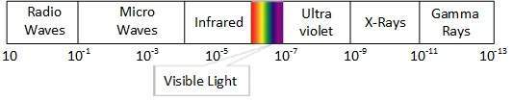

## **Radio Transmission**

Radio frequency is easier to generate and because of its large wavelength it can penetrate through walls and structures alike.Radio waves can have wavelength from 1 mm – 100,000 km and have frequency ranging from 3 Hz (Extremely Low Frequency) to 300 GHz (Extremely High Frequency). Radio frequencies are sub-divided into six bands.

Radio waves at lower frequencies can travel through walls whereas higher RF can travel in straight line and bounce back.The power of low frequency waves decreases sharply as they cover long distance. High frequency radio waves have more power.

Lower frequencies such as VLF, LF, MF bands can travel on the ground up to 1000 kilometers, over the earth’s surface.

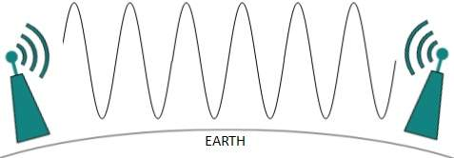

Radio waves of high frequencies are prone to be absorbed by rain and other obstacles. They use Ionosphere of earth atmosphere. High frequency radio waves such as HF and VHF bands are spread upwards. When they reach Ionosphere, they are refracted back to the earth.

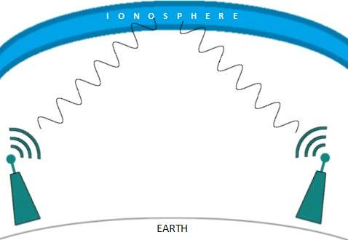

## **Microwave Transmission**

Electromagnetic waves above 100 MHz tend to travel in a straight line and signals over them can be sent by beaming those waves towards one particular station. Because Microwaves travels in straight lines, both sender and receiver must be aligned to be strictly in line-of-sight.

Microwaves can have wavelength ranging from 1 mm – 1 meter and frequency ranging from 300 MHz to 300 GHz.

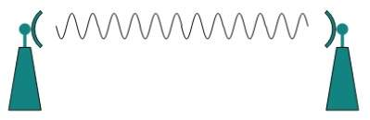

Microwave antennas concentrate the waves making a beam of it. As shown in picture above, multiple antennas can be aligned to reach farther. Microwaves have higher frequencies and do not penetrate wall like obstacles.

Microwave transmission depends highly upon the weather conditions and the frequency it is using.

## **Infrared Transmission**

Infrared wave lies in between visible light spectrum and microwaves. It has wavelength of 700-nm to 1-mm and frequency ranges from 300-GHz to 430-THz.

Infrared wave is used for very short range communication purposes such as television and it’s remote. Infrared travels in a straight line hence it is directional by nature. Because of high frequency range, Infrared cannot cross wall-like obstacles.

## **Light Transmission**

Highest most electromagnetic spectrum which can be used for data transmission is light or optical signaling. This is achieved by means of LASER.

Because of frequency light uses, it tends to travel strictly in straight line.Hence the sender and receiver must be in the line-of-sight. Because laser transmission is unidirectional, at both ends of communication the laser and the photo-detector needs to be installed. Laser beam is generally 1mm wide hence it is a work of precision to align two far receptors each pointing to lasers source.

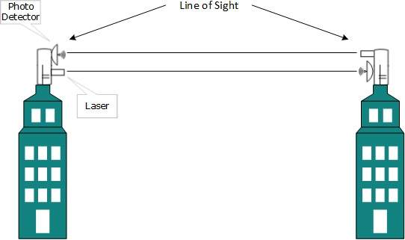

Laser works as Tx (transmitter) and photo-detectors works as Rx (receiver).

Lasers cannot penetrate obstacles such as walls, rain, and thick fog. Additionally, laser beam is distorted by wind, atmosphere temperature, or variation in temperature in the path.

Laser is safe for data transmission as it is very difficult to tap 1mm wide laser without interrupting the communication channel.

1. Explain Bluetooth Architecture in detail.

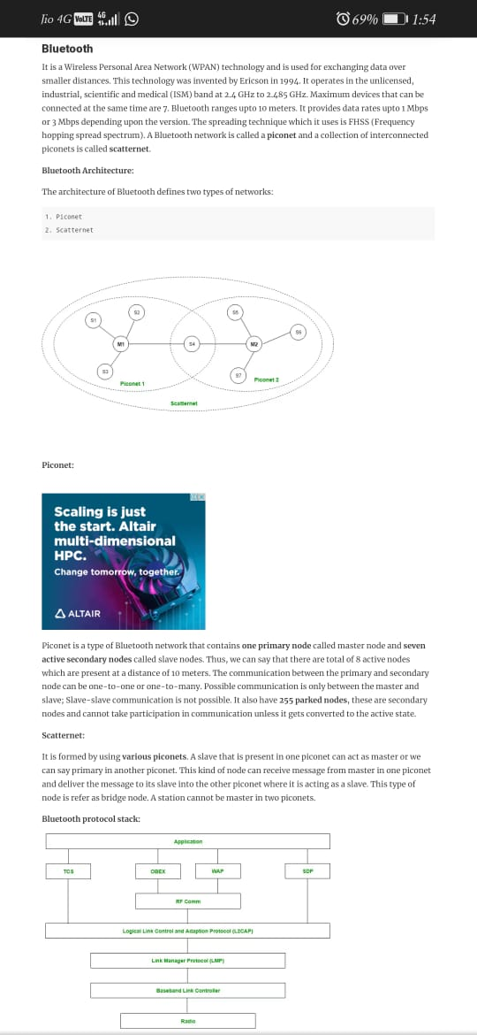

1. What are the advantages of the adaptive routing approach over non-adaptive routing?

| 1. **Adaptive Routing Algorithms** | **Non-Adaptive Routing Algorithms** |
| --- | --- |
| Adaptive routing algorithms make routing decisions dynamically depending on the network conditions. | Non-adaptive routing algorithms do not change the selected routing decisions for transferring data packets from the source to the destination. |
| They use the principle of dynamic routing. | They use the principle of static routing. |
| Here, the routing paths are available in dynamic routing tables that are refreshed based on network traffic and topology. | Here, the routing paths are stored in static routing tables which are constructed based upon the routing information stored in the routers when the network is booted up. |
| The complexity is high. | The complexity is lower. |
| They are more frequently deployed in computer networks since most networks are prone to frequent changes and these algorithms can adjust to the changes. | They are preferred for computer networks which are not susceptible to changes. So, their usage is limited. |
| The categories of adaptive routing algorithms are − | The categories of non-adaptive routing algorithms are − |

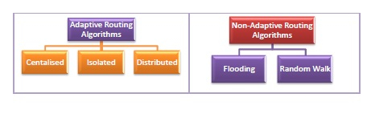

1. The major problem with the distance-vector algorithm is ‘count to infinity. How exchange of complete path from router to destination instead of delay helps solve the count to infinity problem.